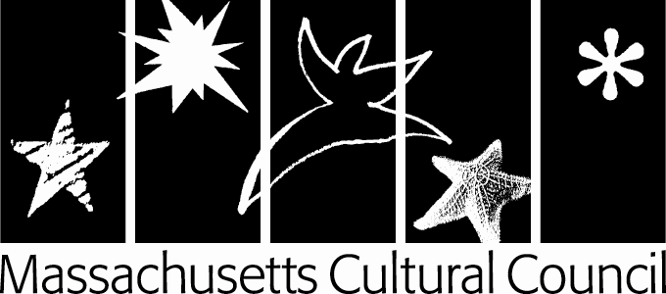
Application Number (for LCC use only) __________________
LCC PROGRAM: FIELD TRIP GRANT APPLICATION
(Formerly known as a “PASS Grant Application”)
This application is being submitted to the LCC.
Please type into the form, print, sign and mail it to the appropriate Local Cultural Council. E-mailed applications will not be accepted.

Click on the underlined blue words to access the Glossary. Important: Use the ‘TAB’ key to move through the application.

APPLICANT INFORMATION

Name:
Address:
City, State, Zip:
Phone: Email:
Website:

Contact Person (if different than applicant):
Address:
City, State, Zip:
Phone: Email:

School/Organization children are affiliated with (if different than applicant):

APPLICANT REQUIREMENTS

To apply for a field trip grant you must meet ALL of the following eligibility and criteria requirements. Please attest that each statement is true by checking the box next to the statement:

I have read and understood any local guidelines and criteria that the Local Cultural Council I am applying to has posted at https://www.mass-culture.org/lcc_public.aspx.

The applicant is (select one):
an individual
an incorporated nonprofit
an unincorporated association or group of people with a nonprofit objective
a public school, library, or other municipal agency
a religious organization or school requesting funds for cultural programming that does not have the effect of advancing religion

Funds will be used to subsidize a cultural field trip for a specific group of children grades Pre-Kindergarten – 12.

Children involved are affiliated with one of the following:
- School (public, non-profit, religious, or home school)
- Afterschool or out-of-school program
- Neighborhood/community center or civic organization

Select one primary discipline for the proposed project/program: Arts Humanities Interpretive Sciences

IF YOU CANNOT AFFIRM ALL OF THE ABOVE, YOU ARE NOT ELIGIBILE FOR A FIELD TRIP GRANT AND CANNOT SUBMIT AN APPLICATION. APPLICANTS SHOULD ALSO MEET ALL OTHER ELIGIBILITY AND CRITERIA FOR LOCAL CULTURAL COUNCIL GRANTS AS DEFINED BY LCC PROGRAM REGULATIONS AND GUIDELINES.

Field Trip Information

Cultural Destination/Program: UMass Amherst Fine Arts Center, Global Arts Series performance of
When will the field trip take place?
Specific grade level(s) participating:

BUDGET

Total # Student Tickets: | 0
Total Student Ticket Request: | $0
Total # Chaperone: | 0
Total Chaperone Cost: | $0
Tour/Guide Fees: | $0
Transportation Request: | $0
Total Amount Requested: | $0

Average amount requested per child: $0 (Total Amount Requested divided by Total # Student Tickets)

How will you adjust the field trip if the council cannot fund the total amount requested? For example, how will you raise additional funds or scale back the field trip?

Authorized Signature: The signature below is that of the person authorized to testify as to the accuracy of this application and the person who agrees that the required acknowledgment will be given to the Massachusetts Cultural Council and the granting local cultural council, if this application is approved. This person also agrees that reasonable accommodations will be made to insure that people with disabilities have equal physical and communications access, as defined by federal law and as outlined in the MCC's LCC Program Regulations and Guidelines.

Signature Date

FOR CULTURAL COUNCIL USE ONLY SUBMITTED BY DEADLINE ___yes ___no

$
Amount Approved Signature of LCC Chair or Authorized LCC Member, Title, Date

